

**Real Numbers**

# Euclid’s Division Lemma:

Given positive integers a and *b,* there exists unique integers q and r satisfying

a = bq + r, where 0 ≤ r < b

* + **Lemma** is a proven statement used for proving another statement.

# Euclid’s Division Algorithm:

* + An **algorithm** is a series of well defined steps which gives a procedure for solving a type of problem.
  + This algorithm is a technique to compute the **H.C.F** of two given positive integers.
  + According to this algorithm, the **HCF** of any two positive integers ‘a’ and ‘b*’,* with a > b, is obtained by following the steps given below:

**Step 1:** Apply Euclid’s division lemma, to ‘a’ and ‘b’, to find q and r, such that a = bq + r, 0  r < b.

**Step 2:** If r = 0, the HCF is b. If r  0, apply Euclid’s division lemma to b and r.

**Step 3:** Continue the process till the remainder is zero. The divisor at this stage will be HCF (a, b).

Also, note that HCF (a, b) = HCF (b, r).

Euclid’s Division Algorithm can be summarized as follows:

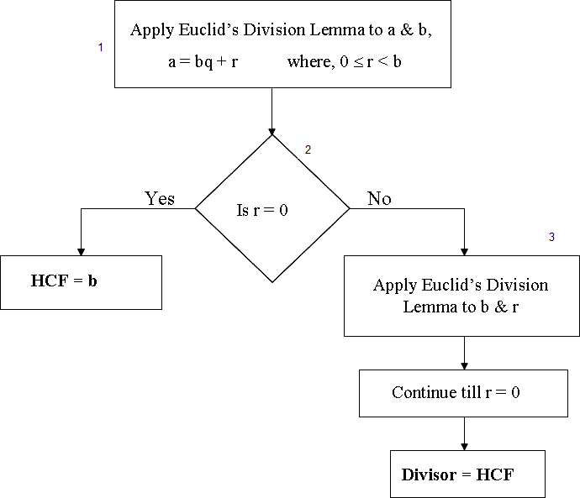

* + Euclid’s Division Algorithm is stated for only positive integers but it can be extended for all integers except zero, i.e., b ≠ 0.

# Real Numbers:

* + The numbers which can be represented in the form of *p* , where *p* and *q* are integers and

*q*

*q*  0

are called **Rational numbers**.

*p*

➢

Any number that cannot be expressed in the form of , where *p* and *q* are integers and

*q*

*q*  0

are

called **Irrational numbers**.

* + There are more irrational numbers than rational numbers between two consecutive numbers.
  + Rational and Irrational numbers together constitute **Real numbers**.

# Properties of Irrational numbers:

1. The **Sum, Difference, Product** and **Division** of two irrational numbers need not always be an irrational number.
2. **Negative** of an irrational number is an irrational number.
3. **Sum** of a **rational** and an **irrational** number is irrational.
4. **Product** and **Division** of a non-zero rational and irrational number is always irrational.

# Fractions:

* + **Terminating fractions** are the fractions which leaves remainder 0 on normal division.
  + **Recurring fractions** are the fractions which never leave a remainder 0 on normal division.

## Properties related to prime numbers:

* + If p is a prime and divides a2, then p divides a, where ‘a’ is a positive integer.
  + If p is a prime, then is an irrational number.



*p*

* + A number ends with the digit zero if and only if it has 2 and 5 as two of its prime factors.

# Decimal Expansion:

* + The decimal expansion of rational number is either **terminating** or **non-terminating recurring (repeating).**
  + If the decimal expansion of rational number **terminates**, then we can express the number in the form of *p* , where p and q are co prime, and the prime factorization of **q is of the form 2n5m**, where

*q*

n and m are non negative integers.

* + If x = *p*

*q*

is a rational number, such that the prime factorization of q is of the form 2n5m

, where *n*, *m*

are non-negative integers. Then, *x* has a decimal expansion which **terminates.**

* + If the denominator of a rational number is of the form 2n5m, then it will terminate after n places if n > m or after m places if m > n.
* The decimal expansion of an irrational number is **non-terminating, non-recurring.**

# Fundamental Theorem of Arithmetic:

Every composite number can be expressed (factorized) as a product of primes, and this factorization is unique, apart from the order in which the prime factors occur.

* The procedure of finding **HCF(Highest Common Factor)** and **LCM(Lowest Common Multiple)** of given two positive integers a and b:

1. Find the prime factorization of given numbers.

## HCF(a, b) = Product of the smallest power of each common prime factors in the numbers.

1. LCM(a, b) = **Product of the greatest power of each prime factors, involved in the numbers.**
2. **Relationship between HCF and LCM** of two numbers:

If a and b are two positive integers, then HCF (a, b)  LCM (a, b) = a  b

# Relationship between HCF and LCM of three numbers:

*LCM* (*p*, *q*, *r* ) =

*HCF* (*p*, *q*, *r* ) =

*p*. *q*. *r* . HCF (*p*, *q*, *r* )

HCF (*p*, *q*).HCF (*q*, *r* ). HCF (*p*, *r* )

*p*. *q*. *r* . LCM (*p*, *q*, *r* )

LCM (*p*, *q*). LCM (*q*, *r* ). LCM (*p*, *r* )